ALADDIN-Does the thought of putting your child’s hair in a bun just add to your already stressful day? Let us help you! We will be offering BUNS and MAKE-UP services for both dress rehearsal and performance day!
BUNRAISER

Volunteers and dancers from the Northeast Atlanta Ballet company will be set up backstage to deliver the perfect hair and make-up for the special day. We will provide all hair bands, nets, pins, spray, and make-up.
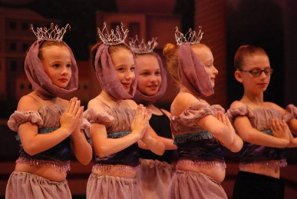
All proceeds from the BUNRAISER will be donated to the Northeast Atlanta Ballet.
Please complete the form below and return to the office to reserve your dancer’s spot.
Dancers must pre-register and arrive 1 hour 15 min. before performance time and 45 minutes before dress rehearsal.
Dancer’s Name: ______________________________________ Phone #___________________
Email _________________________________________________________________________
THE ROYAL TREATMENT $20.00 Hair & Make-Up
*Choose 1 Dress Rehearsal and 1 show. Add $8 for each additional show DAY.
Dress  Rehearsal  May 13th | Show  Friday 7:30  May 14th | Show  Friday 7:30  May 15th | Show  Friday 7:30  May 16th | Total $
Hair Only $8.00 each performance or rehearsal
Dress  Rehearsal  May 13th | Show  Friday 7:30  May 14th | Show  Friday 7:30  May 15th | Show  Friday 7:30  May 16th | Total $
Make-Up Only $6.00 each performance or rehearsal
Dress  Rehearsal  May 13th | Show  Friday 7:30  May 14th | Show  Friday 7:30  May 15th | Show  Friday 7:30  May 16th | Total $

I have enclosed my payment in the amount of $__________ Check #_______________ or Cash_______________
Please bill my credit card in the amount of $_______________ (please add $2.50 charge for credit card purchases)
Card #______________________________________________EXP.Date___________________SEC Code__________

